1. (a) 1/ 695 (There are 695 non-block cells.)

(b)

The method : There are mostly 4 situations, left side, right side, up side, or down side. Instead, let's see the simple case. There are 10 cells in a row, and the exit is located above the 6th cell. There are two extreme cases, [5R(move right five time), 1U(move up once)] and [4L, 1U]. The shortest way is [5R + 4R , 4L, 1U], which is aggregated points in one dead end point, then move to the end point together.

Now, let's assume the 2-dimension case, 10 cells in each four sides. To aggregate in one point, for example in right upper corner, the extreme case is that [9U,9R] or [9R,9U]. If we try the 'right' first, the problem is that the left and right side points couldn't move. Thus, [9U,9R] and [9U] are next cases. Thus, the final move would be [9R, 9U, 9R].

Phase 1 : Get out from innermost square.

To get out from this small square, each point have different shortest path. For example, from the upperleft corner cell, it need to move [1R, 4D] to get out. The other possible case is [1L, 4D]. The important thing is that to ensure that every points could successfully get out from the cell, we need to aggregate the whole points in one point then get out. Thus, firstly, aggregate them. We have 3 choices, right, left, and down. Choose 'right'. To aggregate them we need to move right twice. Then points are aggregated in right side. Now, we have two choices, down or left. Choose 'left'. Then, choose down to get out from that cell. The total move from the first phase is 7, which is [2R, 1L, 4D].

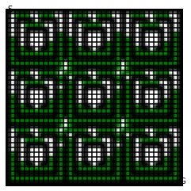 : (Innermost square is now empty.)

Phase 2 : Get out from the mid square

It is the case of 2-dimension case. The possible case is [6R,6U] or [6U,6R]. Thus, move [6R, 6U, 6R] to aggregate in upper right corner, then move [3L, 2U] to get out.

: (Innermost and middle square are both empty.)

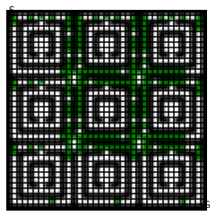

Phase 3 : Get out from the outer square, move to the 9th district and aggregate the point

If we assume that there is no exit, we can aggregate points by moving [10R, 10D]. However, among 9 districts, only 5 districts (3,6,7,8,9) could aggregate the points to the corner. We only need to achieve the above 1/2 success rate, so let's ignore the other districts. Now, most of points are aggregated in 5 points. To get into the district 9, the cases are [10U, 14R], [10L, 14D]. Lets choose the 10L first. To aggregate the 3 big points in district 3,6,9, we need to choose the 24D. Now, to aggregate 3 big points, move [10U, 34R].

The move [10L, 14D + 10D, 10U, 14R + 10R] is to get in the district 9, and [10R] is to aggregate them. The total is 98, which is [10R, 10D, 10L, 24D, 10U, 34R].

: (most of points are aggregated in 9th district's right upper corner)

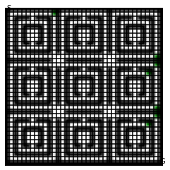

Phase 4 : Into the goal

Now, it is simple. The most of points are aggregated in right upper corner in district 9. To the destination, move [5L, 2D, 3R, 6D, 3L, 3U]. The total move is 22.

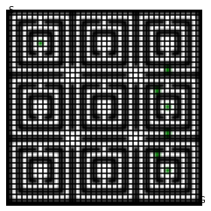 : Final Output

The success rate is 0.745 and the total move is 150.

(c)

Let's see the result plot in each phase to see if there are any moves that is unnecessary, or enhance the overall success rate. See the figure1. In phase2, if we move down only once, then we can aggregate the point in up, right, and down side. So, we can replace [6R, 6U, 6R] to [1D, 6R, 6U].

See figure2. In phase3, if we move up once, then we can aggregate the left side into one point.

To aggregate points into one side as much as possible, move [34R] instead of [10R]. Also, move [34D] instead of [10D]. Then, the rest of steps are same as above. Thus, the total move is 194, and success rate is 1.

: Final Output

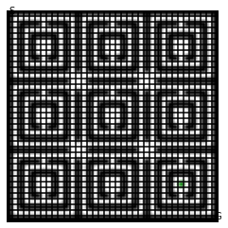

(d1)

First, I created a map to see the number of surrounded blocks in each cell. The issue here is that the corner cell's block number is different with the nearby cell's block number. If we move left, then the some points will be aggregated in the left corner. However, the two aggregated points in one cell has different observations. Thus, the possible cell's probability should be the same.

In this case, there are 128 possible points. Thus, the probability is 1/128.

(d2)

As I mentioned above, the probability of each possible cells are the same. For example, I test the obs = [5,6,6], and move = [right, up]. There are 33 possible points. The probability is 1/33 in each cell.